**Lab Practical #10:**

Study the concept of routing using packet tracer.

**Practical Assignment #10:**

1. Connect the two different networks based on the calculated IP addresses and subnet using a packet tracer. (Static & Dynamic Routing).

Static:

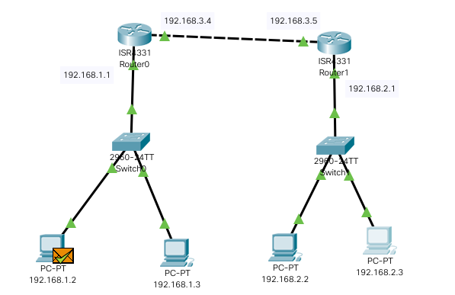

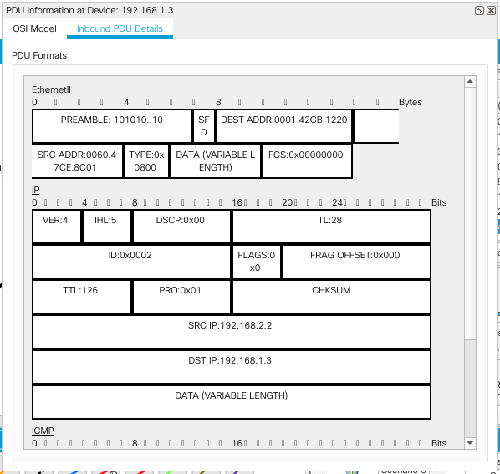

Dynamic:

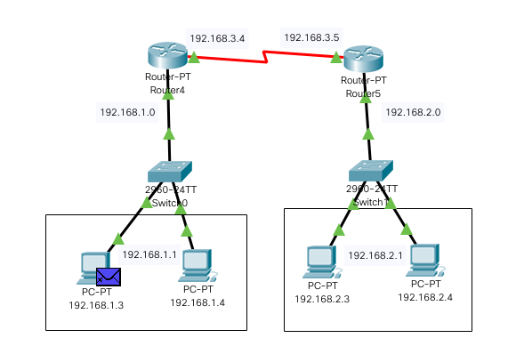

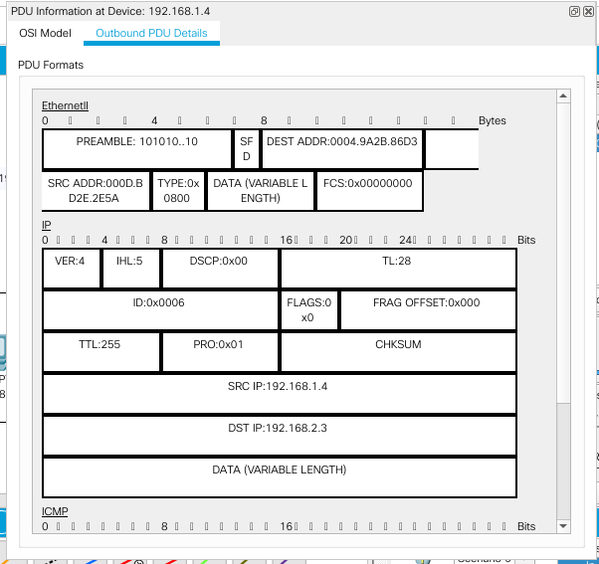

1. Connect the three different networks based on the calculated IP addresses and subnet using a packet tracer. (Static & Dynamic Routing).

Static:

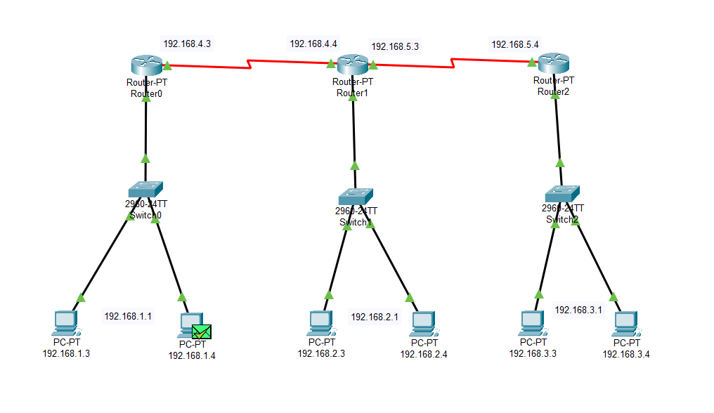

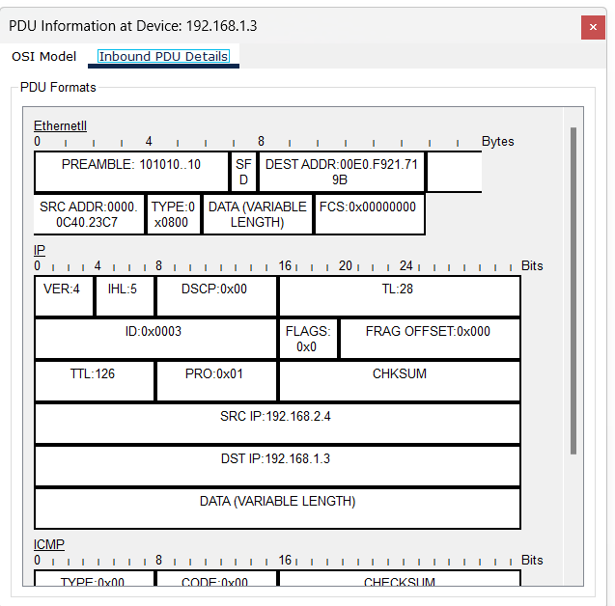

Dynamic:

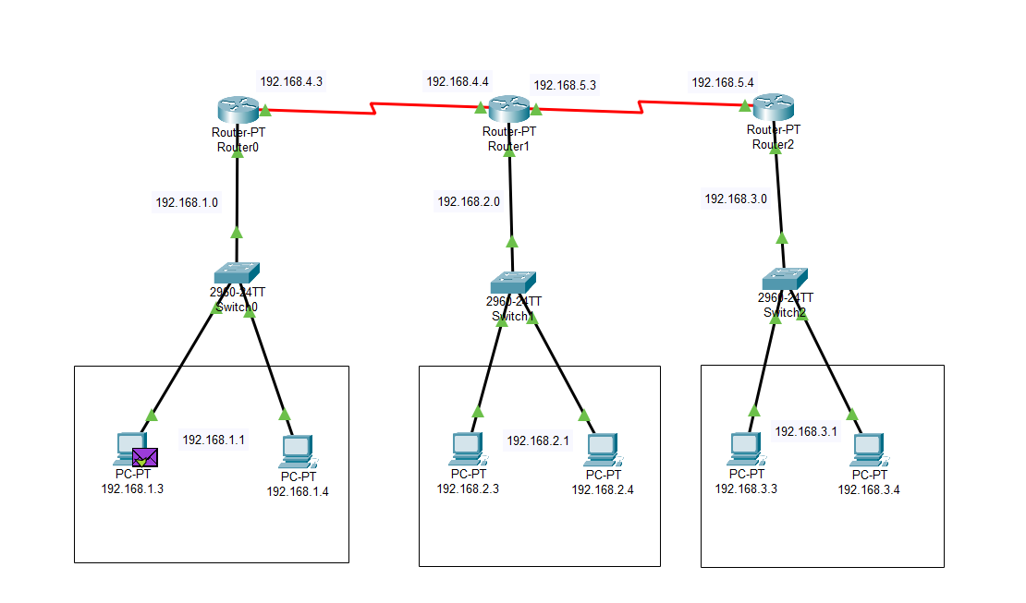

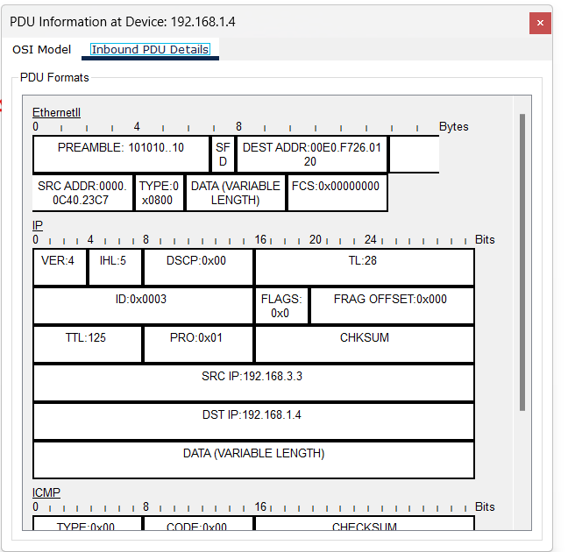

Instructions:

1. Static routing screenshot with routing table. (Take two or more different networks)

2. RIP routing screenshot with routing table. (Take two or more different networks)

3. Mention IP address of each node and network ID of each network as label.

4. Ping command / Packet transfer screenshot between two different network nodes.